Customization 1
- Upload Items to Cart Feature: 120hs
- Create one script to allow the upload of a Comma Separated Value (CSV) file
- Create one script to add line items and their quantities to the shopping cart page from an uploaded CSV File
Regarding customization 1 (150hs on CSER, 80hs on pricing calculator):
- Do you want to show this csv file in any section of the cart module or you only want it on backend?
- Can we get an example of this CSV structure?
- Which will be the condition to trigger this CSV file addition to the cart? Do you want to trigger the script and update the customer cart exactly the momento that client uploads the CSV File on backend?

SuiteCommerce Standard
Password protected
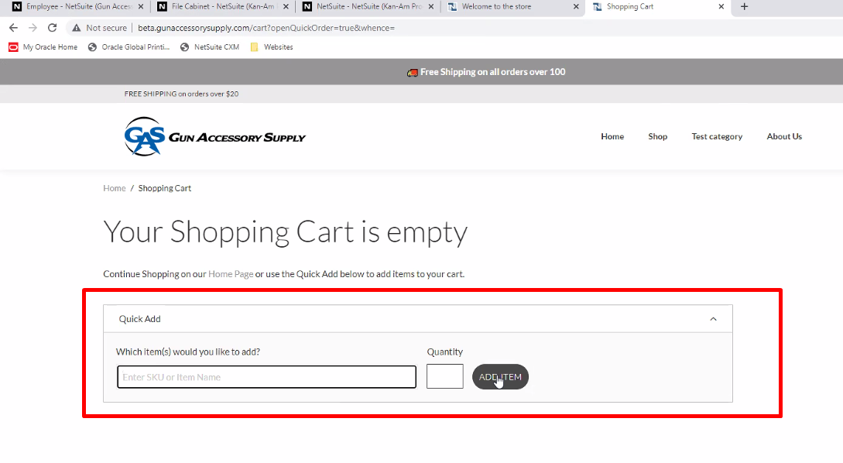
Add CSV import button, that will allow to add all items to the cart through csv, that will read the csv.
After customer is logged in, on quick order view, the client desires to see an import CSV Order section which contains a “Download template” button and an import file button: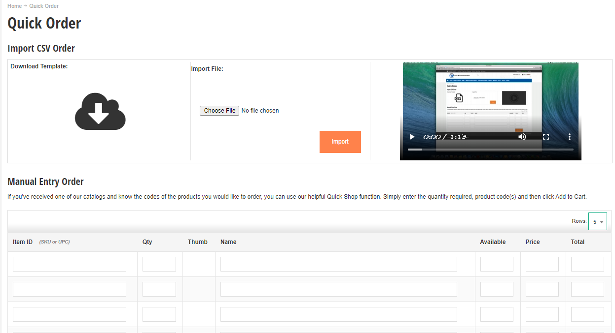

If client press on “download template” it will download the example CSV that the client needs to use to add certain items to cart.
“Import File” button will allow the user to import the CSV created following the template given. Format of CSV will be the following:
SKU Quantity
On SKU client will pass the complete product SKU (with item options). There can be matrix items, but just by passing the complete name with options selected, we can retrieve given the SKU, the internal id of the item and add it to cart.
Once “import file” is pressed, a pop up window will show up to be able to select the appropriate CSV file. Customer will select the appropriate CSV file, and this file will be processed.
Our extension will process each of the lines of the CSV and will start adding to cart each item mapping it’s sku and adding its quantities to cart and item options. This process can take a little while. All the lines from the CSV up to 20 will get added to cart, and a result message will show up after the import:
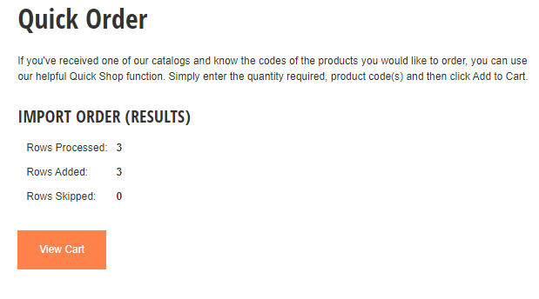
This result section will show how many rows from the CSV were processed, how many were added to cart, and how many were skipped / not added to cart.

Not any orders nor anything, just adding them to the cart.

Quick add is not customizable in SC.

They will have limitations with user experience
CSV can not have more than X lines. After 20 or 30 lines the site starts to work slowly. Each line is going to take several seconds. Multiple request to the driver.

How to do
Retrieve from the SKU the internal id somehow (use nlapiSearchRecord). Then call the add to cart function.
See add to cart customization (you need item options, quantity and internal id
Extensibility layer, or use a custom service using commerce API
Then showing message that will say

What happens when there is an item on the cart that fails? Maybe we need to do add Item one by one

Make the template customizable, so if they add a new item option the template, our algorithm can work with the new template on the csv.

Item options:
We add headers onto csv file, where the header is the id of the item option ,and below, values. That’s how we parse the info and add it to cart.

Debemos usar un servicio 1.0, porque no podemos hacer el addToCart a la orden con un servicio 2.0

Leer CSV
No hace falta que obtenga el dato del input del template, lo agregue el CSV a netsuite y obtener el ID y cargar con nFile, sino que puedo leer el CSV directo con javascript y sacar los datos que necesito.
Si puedo obtener el dato del input.
Pero como me ponen el SKU, necesito un servicio
Cuando el tipo le de el import, se sube, este ejemplo lo hice en el otro proye

Ver ejemplo de IWT.

Estructura
Tengo 3 archivos, serviceController, el entry point del service controller y después model.js.
En assets/services tengo el archivo que hace referencia también al ServiceController.

Desde la vista
Con esta llamada se sube al servicio, en vez de la 2, llamo con SuiteScript y mi servicio, y se le pasa el form que estoy usando en la vista:

formData = new FormData($customFileForm[0]);
jQuery.ajax({
url: Utils.getAbsoluteUrl(
getExtensionAssetsPath(‘services/CSVToCart.Service.ss'),
true
),
data: formData,
dataType: 'json',
type: 'POST',
contentType: false,
processData: false,
beforeSend: function beforeSend(jqXHR) {
jqXHR.setRequestHeader('X-SC-Touchpoint', SC.ENVIRONMENT.SCTouchpoint);
}
}).then(function afterUploadingFile(data) {
if (data.error) {
deferred.reject('Error uploading custom file' + (data.details ? ': ' + data.details : ''));
return;
}

deferred.resolve();
});

De aca se llama al servicio y de ahí al modelo.
Agregar el type=”button” al template, sino no anda.

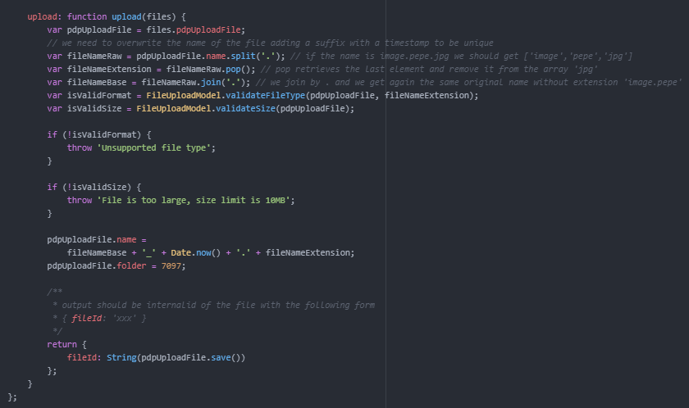

Con el Ajax, llamo al servicio directo, no necesito modelo de frontend.

Pedir al file
Esta documentación esta en realidad en un pdf que dice SuiteScript 1.0 Documentation

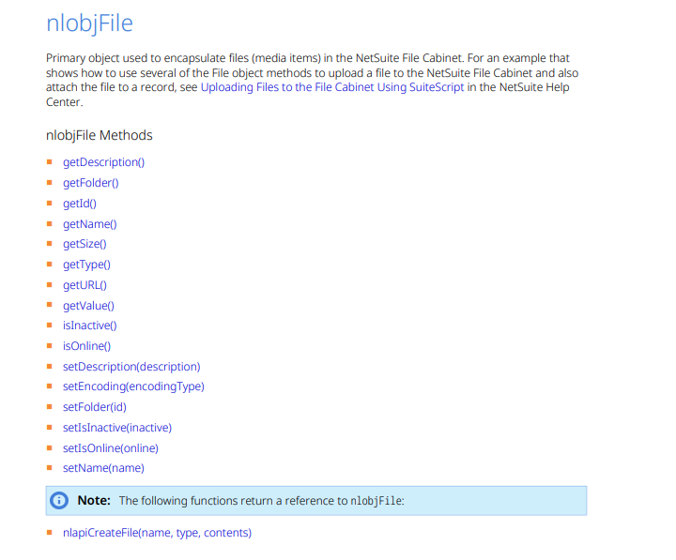
Es un nlobFile, que lo cargo en el ServiceController con:
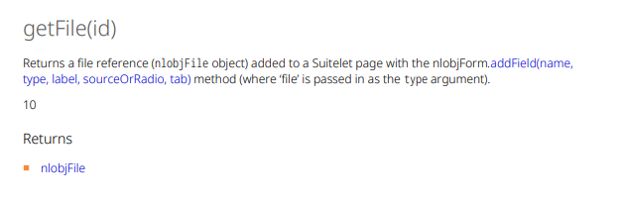
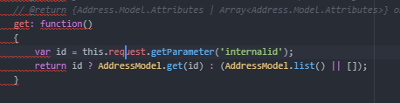
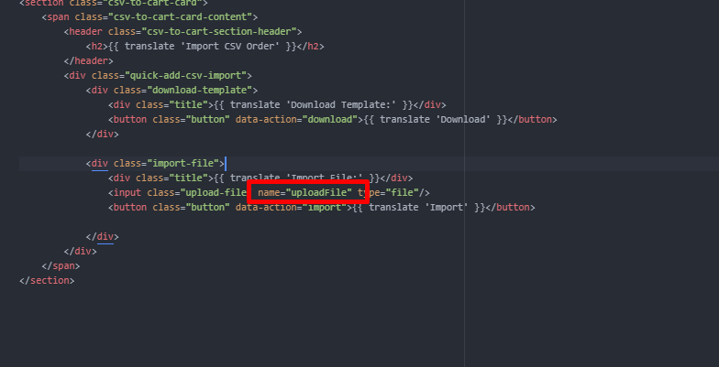
Haces this.request.getFile(‘uploadFile’); es el nombre que viene del template. Esto te va a devolver el nlobjFile.
Luego uso las operaciones del nlobjFile.
https://nlcorp.app.netsuite.com/help/helpcenter/shared_resources/PDF/SuiteScript10API.pdf?whence=

Modelo
Luego, llamo al modelo una vez que tengo todo: como por ejemplo AddressModel.get y le paso el nlobjFile
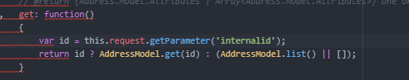
Hago todas las operaciones, le paso el nlobjFile al modelo, luego con otra función

Add to cart
Debería ser SuiteScript solo, sin 1.
Luego usar commerceAPI. Voy a NetSuite, commerce Api y llamo a estas operaciones desde mi modelo:
Uso operaciones de la orden actual: nlapiGetWebContainer().getShoppingSession().getOrder()
Luego entro en “order methods” y uso addItems
https://nlcorp.app.netsuite.com/app/help/helpcenter.nl?fid=section_N2506263.html#bridgehead_3995047899

Customization 2

- Stock message feature: 30hs
  - Modify the PDP to display a custom stock message according to product stock threhshold values

Regarding customization 2 (79hs on CSER, 20hs on pricing calculator):
- What are these product stock threshold values? I saw on the CSER says: up to 3 x stock threshold values on PDP (low, med, high)
- Is there a specific section that they want to show it?
- example of a message?

Item 1 has 10000 on hand, but they do not want to show 10000, instead they would to show 1000+
They would like to have a global field to set the treshhold.

If item is 800, it will show 800, if it is 1001 it will show 1001 if the threshold is 1000.

That is global threshold
But if there is item threhshold we would use that.

Global field threshold – 1000
Item level threshold – 500
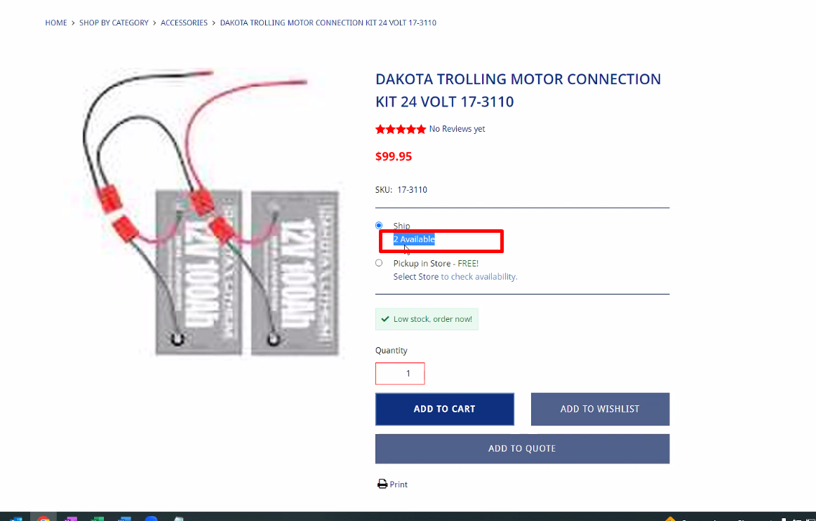

Global threhshold on configuration file.
Item threshold on custom item field.
If the product is out of stock, we won’t show the message (?)
We show a message saying out of stock behavior

Implementation:
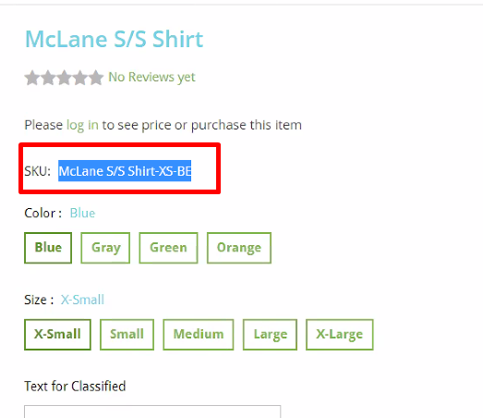
I have got the child SKU, so I can create a service that will call a search that will obtain once from all, all the
var cart = container.getComponent('Cart');
cart.addLine({
line: {
quantity: 1,
item: {
internalid: 8058
}
}
}).then(function() {
alert(Utils.translate('Item added.'))
});

Y las item options cuando las piden?
En average tienen menos de 20

